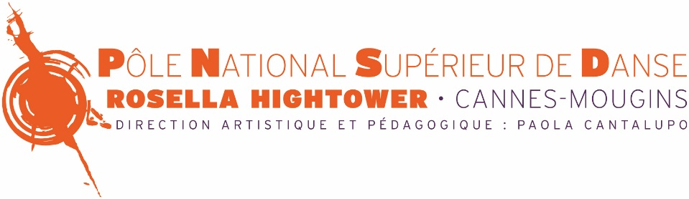

INFORMATIONS ABOUT VIDEO AUDITIONS

APPLICATION FORM FOR A VIDEO AUDITION
Upper School / DNSP Programme
SCHOOL YEAR 2022/2023

How to choose between on-site public audition and video audition?

On-site public audition through a dance class is the most common way for dance schools and professional companies to select new students or dancers.

From the school’s point of view:
Live art par excellence, dance can be best and most naturally assessed live. It is easier to assess a candidate’s potential by meeting him or her in person, by watching him or her moving among other same-age applicants for the same level. It is also simpler to perceive the candidate’s capacity for attention, for auto-correction and to see him or her moving throughout class (endurance, resistance, adaption, comprehension…). It is also the occasion to meet the candidate and his or her family and to better understand the candidate’s aspirations and personal and professional projects.

From the candidate’s point of view:
Going physically to the school that the candidate would like to join is also the occasion to discover the site, its facilities, the offered services, to meet the dance teachers and the staff, to feel the place’s atmosphere.
This procedure is often useful to look to the future environment and to imagine how it would be to be a student there. It is also the occasion to exchange with the other candidates, to meet other young dancers with different backgrounds. It is a chance as well to ask the staff questions about the school.

Video audition can be a very useful option for those candidates who cannot take part to a public audition. This year, due to the calendar’s modifications, this solution can resolve a certain numbers of situations. A precise sequence of elements that must be filmed will enable candidates to calmly prepare their exercises and then to film them.

If the video is well made, it will enable the jury to correctly observe important elements such as placement, coordination, physical potential, sense of music… But of course, no exchange nor interaction between the candidate and the school staff.

If the video isn’t enough for the jury to get a correct and global idea and to make a decision about the candidate’s admission, the jury reserves the right to invite the candidate to present a private audition in person or to participate to a public audition, according to the possibilities.

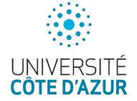
Administration Siège social
140 Allée Rosella Hightower 5 Rue de Colmar
06250 MOUGINS 06400 CANNES
Tel: 04 93 94 79 80 - Siret: 824 547 145 00014 - info@pnsd.fr - www.pnsd.fr

ID PHOTO

APPLICATION PROCEDURE
APPLICATION FORM FOR A VIDEO AUDITION
Upper School / DNSP Programme
SCHOOL YEAR 2022/2023
*Fill in and tick the chosen options
Fully completed application forms must be returned before April 30th 2022 with the requested
Documents and a video link . Incomplete applications will be automatically rejected.
CANDIDATE
Family name : Name : Girl Boy
Date of birth : Place of birth : Nationality :
Full address :
Zip code : City : Country :
Home tel : Fax : Mobile phone :
Email :
*IMPORTANT : Every communication will be done through this email
Height (cm) : Weight (kg) :
FAMILY INFORMATION
Father : Family name : Name : Occupation :
Mother : Family name: Name : Occupation :
Brothers & Sisters: Numbers : Ages :
OTHER INFORMATION
I have already participated to a PNSD Rosella Hightower audition : yes no
If yes, which session ? :
Subject to admission and room availability, for school year 2022/23, I wish to be considered for accomodation : yes no
1/4

TRAINING & EDUCATION BACKGROUND (last three years)
DANCE TRAINING
How old were you when you started dance training ?
Please, indicate how many years you have studied for each of the following ?
- Ballet :
- Contemporary dance :
This current school year (2021/22), how many classes per week do you take (in hours) ?
- Ballet :
- Contemporary dance :

ATTENDED DANCE SCHOOLS
NAME : DATES : TECHNIQUES : TEACHERS :

DANCE DIPLOMAS OBTAINED :

PERFORMANCES / SHOW EXPERIENCES
Have you ever taken part to some performances ? yes (specify) no
DATES : PERFORMED BALLETS OR PIECES :

ACADEMIC EDUCATION
What academic class are you currently attending (2021/22) :
Last diploma obtained and year of graduation :
What is your level in French ? (*Academic classes will be in French only)
SPOKEN : beginner intermediate advanced
WRITTEN : beginner intermediate advanced

2/4

Documents to provide :
APPLICATION CHECK-LIST
- This 4-page application form
- An ID photo (girls : hair in a ballet bun)
- A motivation letter
- A detailled artistic and academic resume
- School report cards for school years 2020/2021 and 2021/2022
(Successful candidates can join our schools only if their application has been approved by our Academic Study Comittee)
- Video link (attached video files will not be accepted)
- Audition fees : 112 €
- Photo in dancing position (one of each)
- Demi plié in 1st position with arms in 2nd
- Tendu devant effacé (open position) with arms in 4th
- A la seconde en l’air en face
- 1st arabesque en l’air de côté (facing side)
- Girls only: sur pointes 4th position croisé with arms in 5th
DVD Requisites
General information:
Video file must show the artistic, musical and technique abilities of the applicant. Framing must be full-length from the beginning to the end in order to show the applicant’s body.
Duration: 15 minutes approximately
Compulsory Contents: The DVD must include the following sequences:
- BARRE : pliés, tendus, adage (including battements lents and/or développés), grands battements
- CENTER
Sequence of pirouettes en dehors and en dedans (on the half-points)
Allegro sequence:
- Small jumps combination and batteries (on the half-points)
- Jumps exercices with assemblés, jetés, sissonnes, etc. (on the half-points)
- Boys : Tours en l’air (to the right and to the left)
- Girls : Points sequence with a diagonale of pirouettes
A classic variation
A contemporary solo
PAYMENT METHODS
- Bank transfert (please indicate name and surname) :
Bank details

Account owner : POLE NATIONAL SUP DANSE PCA
Domiciliation : CANNES ENTREPRISES

Bank code Agency code Account no. RIB Key
30077 04942 11636600201 75

IBAN : FR76 3007 7049 4211 6366 0020 175
BIC : SMCTFR2A

- French cheque : in euros to the « PNSD »
- Online : https://www.pnsd.fr/paiement-en-ligne/
3/4
- By phone (with a credit card) : +33 (0)4 93 94 79 84

APPLICATION ADDRESS
Email : audition@pnsd.fr
Postal address : PNSD Rosella Hightower – Service auditions – 140 Allée Rosella
- Hightower – 06250 Mougins – France
RESULTS COMMUNICATION
Applicants will receive an answer by email before June 8th 2022.
If the video isn’t enough for the jury to get a correct and global idea and to make a decision about the candidate’s admission, the jury reserves the right to invite the candidate to present a private audition in person or to participate to a public audition, according to the possibilities.
No correspondence or discussion can be entered into the result of an audition.
4/4

